EXP 13: PERFORMANCE EVALUATION OF 8-QAM AND 16-QAM COMMUNICATION SYSTEMS UNDER AWGN USING BER, CONSTELLATION AND EYE DIAGRAM ANALYSIS IN MATLAB
SOFTWARE USED : MATLAB SOFTWARE

CODE :
clc; clear; close all

N=12000; SNR=10; sps=8;
b8=randi([0 1],N,1); b16=randi([0 1],N,1);

x8=qammod(bi2de(reshape(b8(1:floor(N/3)*3),3,[])','left-msb'),8,'UnitAveragePower',true);
x16=qammod(bi2de(reshape(b16(1:floor(N/4)*4),4,[])','left-msb'),16,'UnitAveragePower',true);

r8=awgn(x8,SNR,'measured'); r16=awgn(x16,SNR,'measured');

d8=qamdemod(r8,8,'UnitAveragePower',true);
d16=qamdemod(r16,16,'UnitAveragePower',true);

ber8=mean(de2bi(d8,3,'left-msb')'(:)~=b8(1:floor(N/3)*3));
ber16=mean(de2bi(d16,4,'left-msb')'(:)~=b16(1:floor(N/4)*4));

subplot(2,2,1),plot(real(r8),imag(r8),'.'),title('8-QAM Constellation'),grid on
subplot(2,2,2),plot(real(r16),imag(r16),'.'),title('16-QAM Constellation'),grid on
subplot(2,2,3),bar([8 16],[ber8 ber16]),title('BER Comparison'),grid on
subplot(2,2,4),eyediagram(real(r16),2),title('16-QAM Eye Diagram')

fprintf('8-QAM BER = %g\n16-QAM BER = %g\n',ber8,ber16);

MODEL GRAPH :
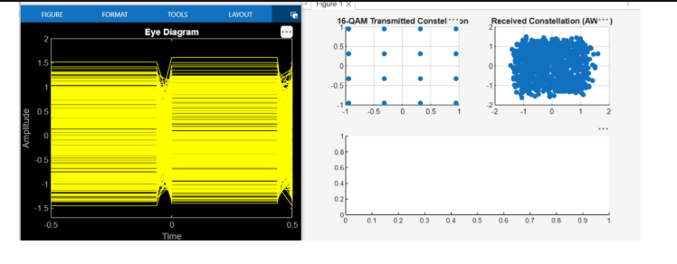

RESULT :
